• **M**ongoDB: A NoSQL database that stores data in flexible, JSON-like documents.

• **E**xpress.js: A web application framework for Node.js, used to build the backend (server-side) of the application.

• **A**ngular (or Angular.js): A frontend framework used for building single-page web applications with dynamic user interfaces.

• **N**ode.js: A JavaScript runtime that allows developers to execute JavaScript on the server side.

Instal angular global.

npm install -g @angular/cli@17

cd C:\Lerning 2024\Angular\AngularMEAN

ng new mean-course --no-standalone ( and enter,enter) will install with ap.modele.ts

ng serve (development only server)

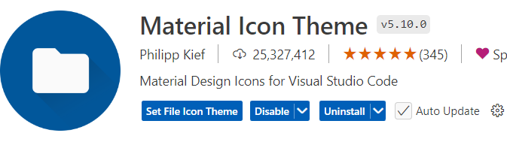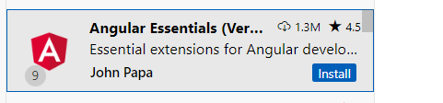

 <textarea matInput rows="4" [value]="newPost" #postInput></textarea>

   <button (click)="onAddPost(postInput)">Save Post</button>

  newPost='no posts';

Using # local ref(#postInput)

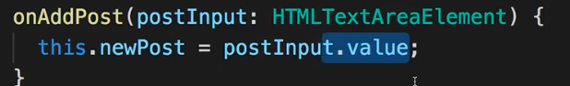

Templete bind

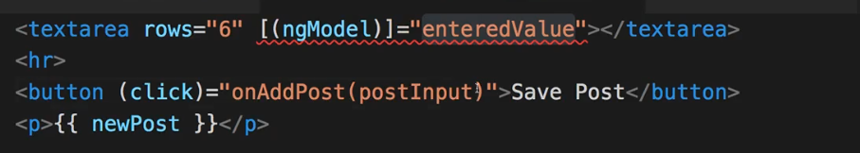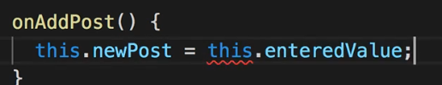



npm install –save @angular/material

if latest version

ng add @angular/material

angular.json will be added

    "styles": [

              {

                "input": "node_modules/@angular/material/prebuilt-themes/indigo-pink.css"

              },

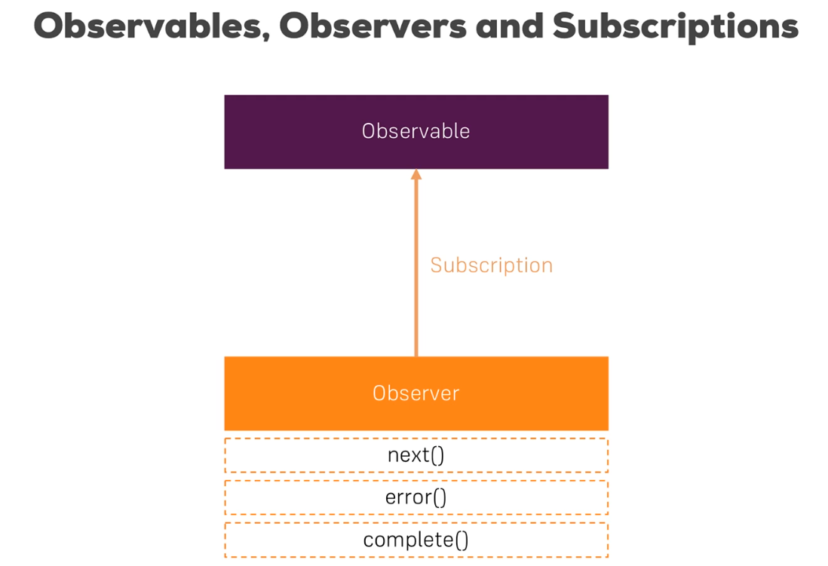

Backend

Add Node backeend

Add server.js on root folder and open new terminal to run it

Run

node server.js

Add express

**npm install --save express**

**Install nodemon to auto update code(no need restart server)**

**npm install --save-dev nodemon**

**Add to package.json**

...

 "test": "ng test",

    "start:server":"nodemon server.js"

  },

Run server npm run start:server

**See what sent on the server side**

**npm install --save body-parser**

const bodyParser = require("body-parser");

app.use(bodyParser.json());

app.use(bodyParser.urlencoded({ extended: false }));

 app.post('/api/posts',(req, res, next) => {

    console.log(req.body);

    res.status(201).json({message: 'Post added successfully'});

   });

Login to terminal

npm install --save morgan

MongoDB

**npm install --save mongoose**

**Image upload**

npm install --save multer

Hash password

**npm install bcrypt –save**

**npm install jsonwebtoken –save**

**Add token to request**

